Shrinkage correlation: GBPUSD and USDJPY
Method 08 / eight-major panel / delta = 0.2 and Ledoit-Wolf / Alpari D1 full available history

Study setup
Logical pair: GBPUSD , USDJPY
Broker symbols: GBPUSD_i , USDJPY_i
Snapshot: 2026-11-03_majors_alpari_D1
Timeframe: D1
Common eight-major panel window: 1999-01-06 to 2026-11-02 (UTC bar dates)
Panel matched return count n: 7127
Dropped unfinished last bar dated 2026-11-03 UTC after a tick-volume check against the prior complete day.
Fixed shrinkage: delta=0.2, mu=3.9170889e-05 (mean of diag(S))
Ledoit-Wolf estimated delta: 0.0042157642
Panel symbols: EURUSD, GBPUSD, AUDUSD, NZDUSD, USDJPY, USDCHF, USDCAD, EURGBP
Complete matched rows (Excel): GBPUSD-USDJPY_Shrinkage_D1.xlsx
Complete matched rows (HTML table): GBPUSD-USDJPY_Shrinkage_D1_data.html

Method carried forward
Shrinkage blends the sample covariance matrix S of matched daily log returns of close, ln(close_t / close_t-1), toward a simple target, then converts the shrunk covariance into correlations. Quotes are not inverted. This experiment builds one common calendar across all eight majors, forms S with the unbiased n-1 divisor, then reports two shrinkage specs: fixed delta = 0.2 with mu equal to the average sample variance (mu * I target), and sklearn Ledoit-Wolf with its estimated delta. Pair reports pull rho_ij from those panel matrices. Same-panel Pearson r is a side check only. Shrinkage improves conditioning; it is not a cause, not a lead, and not a trading signal.

Results
pearson_r | rho_02 | rho_LW | rho_02_minus_r | rho_LW_minus_r | delta_LW
-0.196287 | -0.153336 | -0.195359 | 0.042951 | 0.000928 | 0.00421576

Conclusion
Over the common 7127-day eight-major panel for GBPUSD and USDJPY (broker quote directions unchanged), fixed-delta shrinkage correlation at delta=0.2 is -0.1533 (negative, weak linear link in this sample). Ledoit-Wolf rho is -0.1954 with estimated delta=0.004216. Same-panel Pearson r is -0.1963 (rho_02 minus r = 0.0430; rho_LW minus r = 0.0009). This does not establish cause, lead-lag, or a lasting trading rule.

Charts
Daily closes
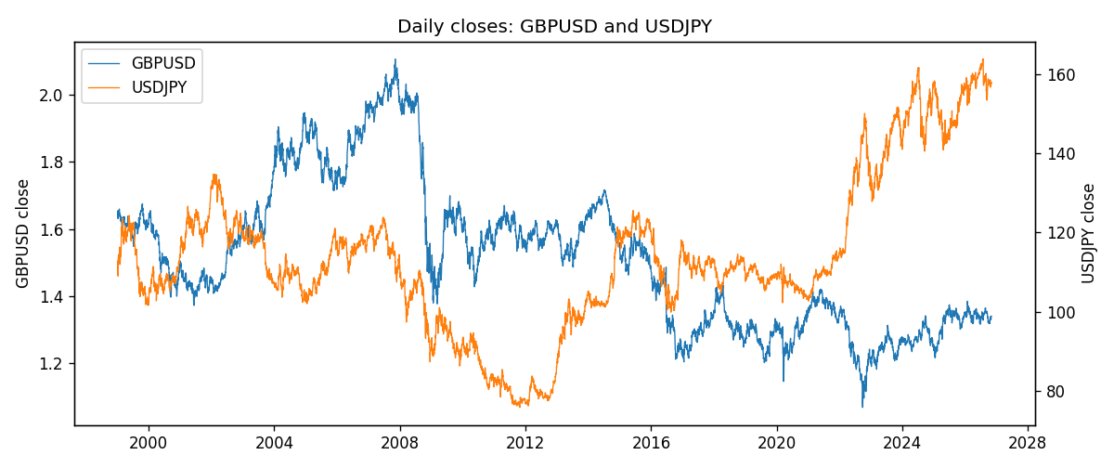
Daily log returns
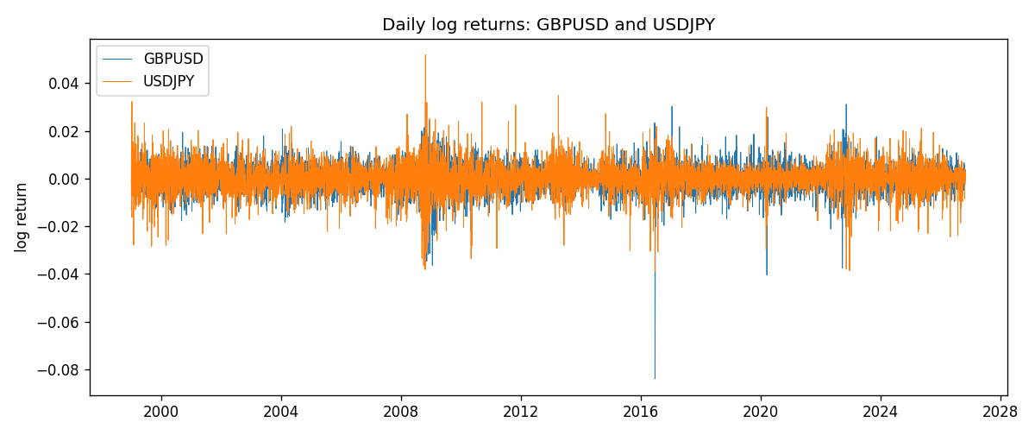
Log-return scatter
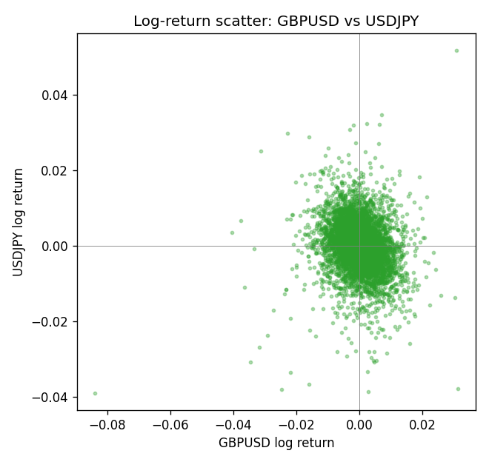

Data report
Every panel row for this pair slice is stored in the sibling Excel workbook named GBPUSD-USDJPY_Shrinkage_D1.xlsx. Full-panel covariance and correlation matrices are saved once under outputs/ as CSV files. Embedding all rows as a Word table is impractical at this length; the Word file holds the column list, column summaries, and the first and last 15 matched rows.
Columns: time, GBPUSD_open, GBPUSD_high, GBPUSD_low, GBPUSD_close, GBPUSD_tick_volume, GBPUSD_spread, GBPUSD_real_volume, GBPUSD_log_return, USDJPY_open, USDJPY_high, USDJPY_low, USDJPY_close, USDJPY_tick_volume, USDJPY_spread, USDJPY_real_volume, USDJPY_log_return
Column summaries (panel rows)
column | count | mean | std | min | 25% | 50% | 75% | max
GBPUSD_open | 7127 | 1.5143204 | 0.21800183 | 1.06854 | 1.323655 | 1.5093 | 1.62967 | 2.1066
GBPUSD_high | 7127 | 1.5206136 | 0.21856742 | 1.08366 | 1.32882 | 1.5159 | 1.636975 | 2.1161
GBPUSD_low | 7127 | 1.508003 | 0.21722806 | 1.03518 | 1.3185 | 1.501 | 1.623 | 2.0983
GBPUSD_close | 7127 | 1.5143843 | 0.21795834 | 1.06879 | 1.32373 | 1.5095 | 1.62965 | 2.1065
GBPUSD_tick_volume | 7127 | 95725.777 | 154086.85 | 62 | 10131.5 | 53562 | 92170 | 1273370
GBPUSD_spread | 7127 | 26.790936 | 19.185969 | 0 | 10 | 20 | 50 | 50
GBPUSD_real_volume | 7127 | 3.5930129e+09 | 8.4874724e+10 | 0 | 0 | 0 | 0 | 2.4038164e+12
GBPUSD_log_return | 7127 | -2.548e-05 | 0.00564718 | -0.08388241 | -0.00312586 | 3.034e-05 | 0.00318105 | 0.03112653
USDJPY_open | 7127 | 113.80058 | 19.291864 | 75.693 | 104.3005 | 110.961 | 120.7475 | 163.824
USDJPY_high | 7127 | 114.29785 | 19.353625 | 76.001 | 104.822 | 111.42 | 121.29 | 163.978
USDJPY_low | 7127 | 113.2782 | 19.219415 | 75.402 | 103.814 | 110.515 | 120.2 | 163.628
USDJPY_close | 7127 | 113.81424 | 19.307121 | 75.811 | 104.298 | 110.98 | 120.725 | 163.851
USDJPY_tick_volume | 7127 | 107141.8 | 179947.68 | 197 | 10056 | 53577 | 93233 | 1803508
USDJPY_spread | 7127 | 20.095973 | 17.5534 | 0 | 6 | 11 | 30 | 50
USDJPY_real_volume | 7127 | 3.5056645e+10 | 1.6155964e+11 | 0 | 0 | 0 | 0 | 3.8834203e+12
USDJPY_log_return | 7127 | 5.336e-05 | 0.00621278 | -0.03908203 | -0.00319557 | 0.00013026 | 0.00340928 | 0.05184024
First 15 panel rows (selected columns)
time | GBPUSD_close | USDJPY_close | GBPUSD_log_return | USDJPY_log_return
1999-01-06 | 1.6537 | 112.77 | -0.00060452184 | 0.0075660159
1999-01-07 | 1.6502 | 111.33 | -0.002118709 | -0.012851583
1999-01-08 | 1.6405 | 110.8 | -0.0058954193 | -0.0047719894
1999-01-11 | 1.6312 | 109.02 | -0.0056851331 | -0.016195423
1999-01-12 | 1.6349 | 112.6 | 0.0022657001 | 0.032310364
1999-01-13 | 1.6499 | 113.52 | 0.0091330396 | 0.0081373171
1999-01-14 | 1.6531 | 113.52 | 0.0019376331 | 0
1999-01-15 | 1.6502 | 114.15 | -0.0017558204 | 0.0055343401
1999-01-18 | 1.6522 | 114.16 | 0.0012112405 | 8.7600193e-05
1999-01-19 | 1.6553 | 113.52 | 0.0018745281 | -0.0056219403
1999-01-20 | 1.6472 | 112.91 | -0.0049053846 | -0.0053879917
1999-01-21 | 1.6524 | 113.87 | 0.0031518998 | 0.0084664056
1999-01-22 | 1.6565 | 114.56 | 0.0024781662 | 0.0060412564
1999-01-25 | 1.6585 | 113.72 | 0.0012066366 | -0.0073594164
1999-01-26 | 1.6597 | 113.86 | 0.00072328374 | 0.0012303367
Last 15 panel rows (selected columns)
time | GBPUSD_close | USDJPY_close | GBPUSD_log_return | USDJPY_log_return
2026-10-13 | 1.32534 | 158.305 | 0.0036434319 | -0.0018932826
2026-10-14 | 1.31884 | 158.317 | -0.0049164679 | 7.5800166e-05
2026-10-15 | 1.32757 | 158.024 | 0.0065976411 | -0.0018524319
2026-10-16 | 1.33257 | 157.964 | 0.0037592051 | -0.00037976126
2026-10-19 | 1.33024 | 158.517 | -0.0017500314 | 0.0034946841
2026-10-20 | 1.3377 | 158.16 | 0.0055923442 | -0.0022546642
2026-10-21 | 1.33937 | 158.108 | 0.0012476328 | -0.00032883504
2026-10-22 | 1.33967 | 156.755 | 0.00022396082 | -0.0085942669
2026-10-23 | 1.33684 | 156.81 | -0.0021146949 | 0.00035080446
2026-10-26 | 1.33359 | 157.458 | -0.0024340661 | 0.0041238746
2026-10-27 | 1.33044 | 157.894 | -0.0023648393 | 0.0027651658
2026-10-28 | 1.33254 | 157.743 | 0.0015771808 | -0.00095679538
2026-10-29 | 1.33733 | 157.683 | 0.0035881935 | -0.00038043789
2026-10-30 | 1.33913 | 157.516 | 0.0013450605 | -0.0010596481
2026-11-02 | 1.3406 | 157.933 | 0.0010971256 | 0.0026438521

